Team Contribution Statements (4 pts)
Team #: 48
Lab section (# and day/time): BB1 (13:00-14:20 W)
- Team contributions
  - Description of each team member’s contribution to the design process

Shihong Yuan:
My main contribution to the modeling phase involved designing the pusher component. I was also responsible for engineering the turntable's center, which I designed with a cross-shaped mechanism to ensure the simultaneous rotation of the entire unit. Upon completion of the individual parts, I took on the critical task of integrating and assembling everyone's models into the final design. Beyond the CAD work, I also assisted with the 3D printing process and completed the necessary expense tracking.
Daniel Koltchev:
My main contribution was designing the crank and link mechanism system (CAD included). I did the calculation and design of the quick-return slider mechanism we are using to push the packages an adequate distance for dispensing. I also assisted in the manufacturing process by using my 3D printer to print necessary components. I also strove to assist my teammates with any questions they had about their own designs.
Sebastian Missong:
My main contribution was designing the box which our mechanism was going to be mounted to. I prepared the dxf’s for laser cutting, designed the brackets and chose the fasteners used to assemble the box. Beyond that I helped throughout the design process and gave input into the design of our linkages and the way that we would assemble the mechanism. I also helped with the slides.
Liangbing Zhao:
I provided alternative schemes for the slide rails and drive turntable. I was mainly involved in the 3D printing of the entire mechanical structure and packages.Besides that, I made renderings and video recordings of the CAD models.

- Signed academic integrity statements: From each team member. Showing they have contributed to, read, and certified the report. There should be one signed statement for each team member. Digital signatures (uploaded picture, tablet, etc.) are acceptable. A missing signature means that the team member will get no credit for the assignment and the rest of the team will get a small penalty for not including them. Forging another team member’s signature means that no team member will get credit for the assignment.
I, __Shihong Yuan______, hereby agree that I followed all academic integrity policies while producing this report. In addition to my original contributions, I have read through this entire report and certify that all materials, including the designs, are correct and not plagiarized.
Signature: ______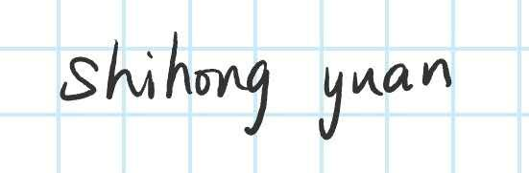_________________________________
Date: _____10/9/2025___________________

I, _________Daniel Koltchev___________, hereby agree that I followed all academic integrity policies while producing this report. In addition to my original contributions, I have read through this entire report and certify that all materials, including the designs, are correct and not plagiarized.
Signature: _______________________________________
Date: __________10/9/2025______________

I, ______ Sebastian Missong_______________, hereby agree that I followed all academic integrity policies while producing this report. In addition to my original contributions, I have read through this entire report and certify that all materials, including the designs, are correct and not plagiarized.
Signature: ________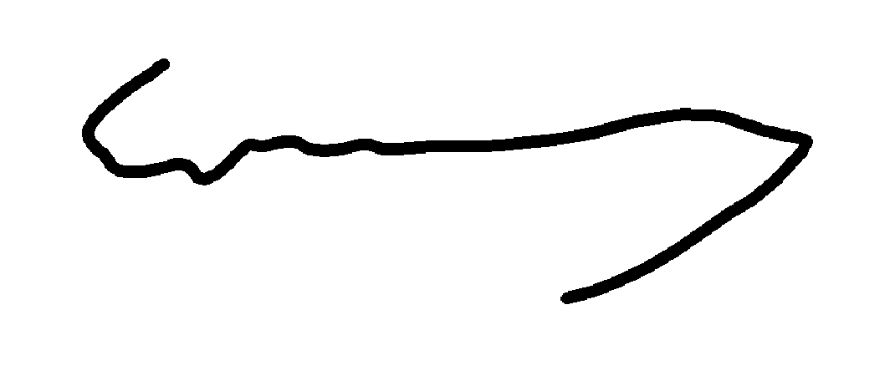_______________________________
Date: ______10/9/2025__________________

I, ______Liangbing Zhao_______________, hereby agree that I followed all academic integrity policies while producing this report. In addition to my original contributions, I have read through this entire report and certify that all materials, including the designs, are correct and not plagiarized.
Signature: _______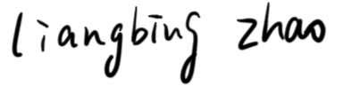____________________________
Date: ______10/9/2025__________________

